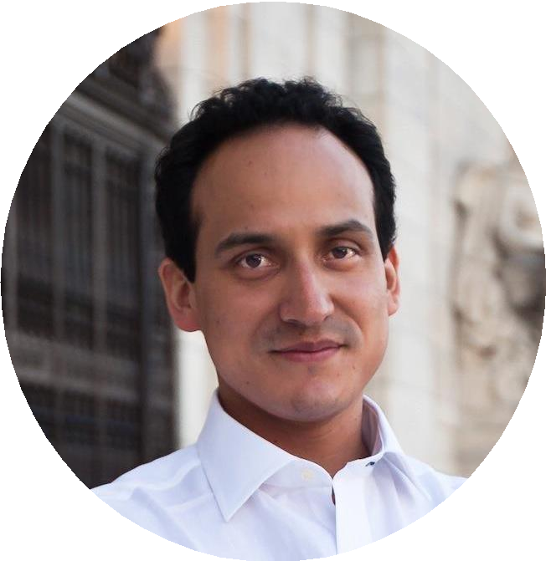
Kristian López Vargas
Follow
Associate professor of economics at the University of California, Santa Cruz

Kristian López Vargas
Department of Economics University of California 1156 High Street
Santa Cruz, CA 95064 kristian@ucsc.edu kmlv.github.io

EMPLOYMENT
2015- Assistant Professor, Economics Department, University of California, Santa Cruz
2015-2016 Visiting Assistant Professor, Department of Economics, University of Maryland

EDUCATION
2015 Ph.D., Economics, University of Maryland 2009 M.Sc., Economics, Texas A&M University
2001 B.S., Social Sciences, Economics. Pontifical Catholic University of Peru

RESEARCH PAPERS

Correcting Misperceptions About Trends and Norms to Address Weak Collective Action
Journal of Environmental Economics Management 2024

Recommended citation: Fuhrmann-Riebel, H., D’Exelle, B., López Vargas, K., Tonke, S. & Verschoor, A. (2022). "Correcting Misperceptions About Trends and Norms to Address Weak Collective Action." Journal of Environmental Economics and Management, 128, 103046. https://doi.org/10.1016/j.jeem.2024.103046

Policies for transactional de-dollarization: A laboratory study
Journal of Economic Behavior and Organization 2022

Recommended citation: Arrieta, J., Florian, D., López Vargas, K. & Morales, V. (2022). "Policies for transactional de-dollarization: A laboratory study." Journal of Economic Behavior & Organization, 200, 31-54. https://doi.org/10.1016/j.jebo.2022.05.012

Algorithmic Assortative Matching on a Digital Social Medium
Information Systems Research 2022

Recommended citation: López Vargas, K., Runge, J. & Zhang, R. (2022). "Algorithmic Assortative Matching on a Digital Social Medium." Information Systems Research, 33(4), 1138-1156. https://doi.org/10.1287/isre.2022.1135

Improving the Cost-Effectiveness of the Conservation Reserve Program: A Laboratory Study
Journal of Environmental Economics and Management 2021

Recommended citation: Cramton, P., Hellerstein, D., Higgins, N., Iovanna, R., López Vargas,
K. & Wallander, S. (2021). "Improving the Cost-Effectiveness of the Conservation Reserve Program: A Laboratory Study." Journal of Environmental Economics and Management, 108, 102439. https://doi.org/10.1016/j.jeem.2021.102439

An oTree-based Flexible Architecture for Financial Market Experiments
Journal of Behavioral and Experimental Finance 2020

Recommended citation: Aldrich, E., Demirci, H. A. & López Vargas, K. (2020). "An oTree- based Flexible Architecture for Financial Market Experiments." Journal of Behavioral and Experimental Finance, 25, 100205. https://doi.org/10.1016/j.jbef.2019.03.007

Experiments in high-frequency trading: comparing two market institutions
Experimental Economics 2019

Recommended citation: Aldrich, E. & López Vargas, K. (2019). "Experiments in High- Frequency Trading: Testing the Frequent Batch Auction." Experimental Economics, 23(2), 322-352. https://rdcu.be/bp5z5

Interpersonal Comparisons and Risk Attitudes in the Field
Economics Letters 2019

Recommended citation: Jaramillo, M. & López Vargas, K. (2019). "Interpersonal Comparisons and Risk Attitudes in the Field." Economics Letters, 179, 16-18. https://doi.org/10.1016/j.econlet.2019.03.011

Multi-Object Auctions with Resale: Theory and Experiment
Games and Economic Behavior 2015

Recommended citation: Filiz-Ozbay, E., López Vargas, K. & Ozbay, E. Y. (2015). "Multi-Object Auctions with Resale: Theory and Experiment." Games and Economic Behavior, 89, 1-16. https://doi.org/10.1016/j.geb.2014.10.008

WORKING PAPERS

Flow Trading: A Laboratory Test
R&R AEJ Micro 2025

Recommended citation: Friedman, D. & Li, Y. & López Vargas, K. (2025). "Flow Trading: A Laboratory Test." Working Paper. https://ssrn.com/abstract=4940168

Can Reminders Promote Regular Pro-Environmental Behavior? Experimental Evidence from Peru
Working Paper 2024

Recommended citation: Fuhrmann-Riebel, H., D’Exelle, B., López Vargas, K., Tonke, S. & Verschoor, A. (2024). "Can Reminders Promote Regular Pro-Environmental Behavior?
Experimental Evidence from Peru." Working Paper. https://ssrn.com/abstract=4844520

Disentangling Risk Attitudes and Other-Regarding Preferences: Theory and Experiment
2023

Recommended citation: Feldman, P. & López Vargas, K. (2023). "Disentangling Risk Attitudes and Other-Regarding Preferences: Theory and Experiment." Working Paper. https://ssrn.com/abstract=4319590

Messenger and Spillover Effects on Infant Immunization: A Field Experiment
2022

Recommended citation: López Vargas, K., Parodi, S., Ramirez, I. & Villa-Paro, P. (2022). "Messenger and Spillover Effects on Infant Immunization: A Field Experiment." Working Paper. https://drive.google.com/file/d/1CpJJZbjSSB9wHco9a5S1l9IYEpvRNTcJ/view?

usp=sharing

Efficiency in Queuing Under Decentralized Mechanisms
2022

Recommended citation: López Vargas, K., Williams, B. & Zhao, S. (2022). "Efficiency in Queuing Under Decentralized Mechanisms." Working Paper. https://ssrn.com/abstract=4321153

On the Demand for Expressing Emotions
R&R from AER 2014

Recommended citation: Grosskopf, B. & López Vargas, K. (2014). "On the Demand for Expressing Emotions." Working Paper.

Correcting Misperceptions About Trends and Norms to Address Weak Collective Action
Journal of Environmental Economics Management 2024

Recommended citation: Fuhrmann-Riebel, H., D’Exelle, B., López Vargas, K., Tonke, S. & Verschoor, A. (2022). "Correcting Misperceptions About Trends and Norms to Address Weak Collective Action." Journal of Environmental Economics and Management, 128, 103046. https://doi.org/10.1016/j.jeem.2024.103046

Separation of Powers and Electoral Rules: A Laboratory Study of Presidential Democracies
2022

Recommended citation: López Vargas, K., Medina, S. & Moromizato, G. (2022). "Separation of Powers and Electoral Rules: A Laboratory Study of Presidential Democracies." Working Paper.

PROFESSIONAL SERVICE
Referee: Management Science, Experimental Economics, Journal of Economic Behavior and Organization, Journal of Economic Psychology, the Economics Bulletin, the International Economic Review, Journal of Behavioral and Experimental Finance, Journal of Economics & Management Strategy.

DEPARTMENT AND UNIVERSITY SERVICE
2021- Director of the LEEPS Laboratory
2021-2022 Committee Member for Microeconomics Seminar Series 2020-2021 Hiring Committee Member - Microeconomic Theory
2020- Member of the Steering Committee of the Center for Analytical Finance (CAFIN) 2016-2020 Co-Director of the LEEPS Laboratory
2016 Review Committee Member, 2016 UC MEXUS-CONACYT Research Grant 2016- Co-committee member for IT (Computing, Library, Web)
2015-2016 Coordinator for the department’s weekly Brown Bag Seminar series

CONFERENCES AND SEMINARS
International Meeting on Experimental and Behavioral Social Sciences (May 2023) Networking Experimental Laboratories and Subject Pools (2023)
LACEA/LAMES Conference (2023, as scientific committee member) LACEA/LAMES (2017, 2021, 2022)
Econometric Society Summer Meeting (2022) Social Choice and Welfare Meetings (2022)
LACEA/BRAIN (2022)
CalPoly (2022, as seminar presenter) BEEC (2018, 2019, 2021, 2022)
Theory and Experiments in Monetary Economics Conference (2022) Economic Science Association World Meeting (2018, 2022)
North American Economic Science Association Meeting (2018, 2021)
Bay Area Behavioral and Experimental Economics Workshop (2019, 2021 as presenter; 2022 as organizer)
LACEA/LAMES Conference (2021, as conference paper reviewer) University of California San Diego (2019, as seminar presenter)
American Economic Association Meeting (2019, as session discussant) George Mason University (2018, as seminar presenter)
Binghamton University (2018, as seminar presenter) Central Bank of Peru (2018, as seminar presenter)
Regional Conference on Experimental Finance (2016, 2017) Stanford Institute for Theoretical Economics (2015)

Toulouse School of Economics (2015, as seminar presenter) Pompeu Fabra University (2015, as seminar presenter)
Australian National University (2015, as seminar presenter) ITAM (2015, as seminar presenter)
Norwegian School of Economics (2015, as seminar presenter)

TEACHING

Individual and Field Studies (UCSC ECON 193, 193F, 199, 199F)

Advanced Applied Microeconomics (UCSC ECON 270)

Behavioral, Experimental, and Theoretical Economics Workshop (UCSC ECON 276)

Dissertation and Thesis Research (UCSC ECON 297A, 298, 299B)

Advanced Microeconomics Theory (UCSC ECON 204B)

Intermediate Microeconomics (UCSC ECON 100A)

ADVISEES AND DISSERTATION COMMITTEES
Rachel Zang (2020) - Data Scientist at Meta. Inc.
Shuchen Zhao (2021) - Assistant Professor Dongbei University, China. Liwei Liu (2022) - Data Scientist at Meta. Inc.
Brett Williams (2022) - Post-doctoral fellow at the AGORA Centre for Market Design at UNSW.
Zhaoqui Wang (2023) - Assistant Professor Jinan University, China. Gregory Klevans (current)
Yilin Li (current)
Weinan Gong (current) Vivian Zheng (current)
Gagandeep Sachdeva (current)

